**Measuring the Pulse of Prosperity: An Index of Economic Freedom Analysis**

**Introduction :**

Economic freedom is the fundamental right of every human to control his or her own labor and property. In an economically free society, individuals are free to work, produce, consume, and invest in any way they please. In economically free societies, governments allow labor, capital, and goods to move freely, and refrain from coercion or constraint of liberty beyond the extent necessary to protect and maintain liberty itself.

For much of human history, most individuals have lacked economic freedom and opportunity, condemning them to poverty and deprivation.

Today, we live in the most prosperous time in human history. Poverty, sicknesses, and ignorance are receding throughout the world, due in large part to the advance of economic freedom. In 2022, the principles of economic freedom that have fueled this monumental progress are once again measured in the Index of Economic Freedom, an annual guide published by The Heritage Foundation, Washington's No. 1 think tank.

We measure economic freedom based on 12 quantitative and qualitative factors, grouped into four broad categories, or pillars, of economic freedom:

1. Rule of law property rights, government integrity, judicial effectiveness)
2. Government size (government spending, tax burden, fiscal health)
3. Regulatory efficiency (business freedom, labor freedom, monetary freedom)
4. Open markets (trade freedom, investment freedom, financial freedom)

**Data Collection**

Data collection is the process of gathering and measuring information on variables of interest, in an established systematic fashion that enables one to answer stated research questions, test hypotheses, and evaluate outcomes and generate insights from the data.

**Data Visualization**

Data visualization is the process of creating graphical representations of data in order to help people understand and explore the information. The goal of data visualization is to make complex data sets more accessible, intuitive, and easier to interpret. By using visual elements such as charts, graphs, and maps, data visualizations can help people quickly identify patterns, trends, and outliers in the data.

**2022 Economic freedom score**

This map/visualization demonstrates the index score of all the 176 countries in the dataset

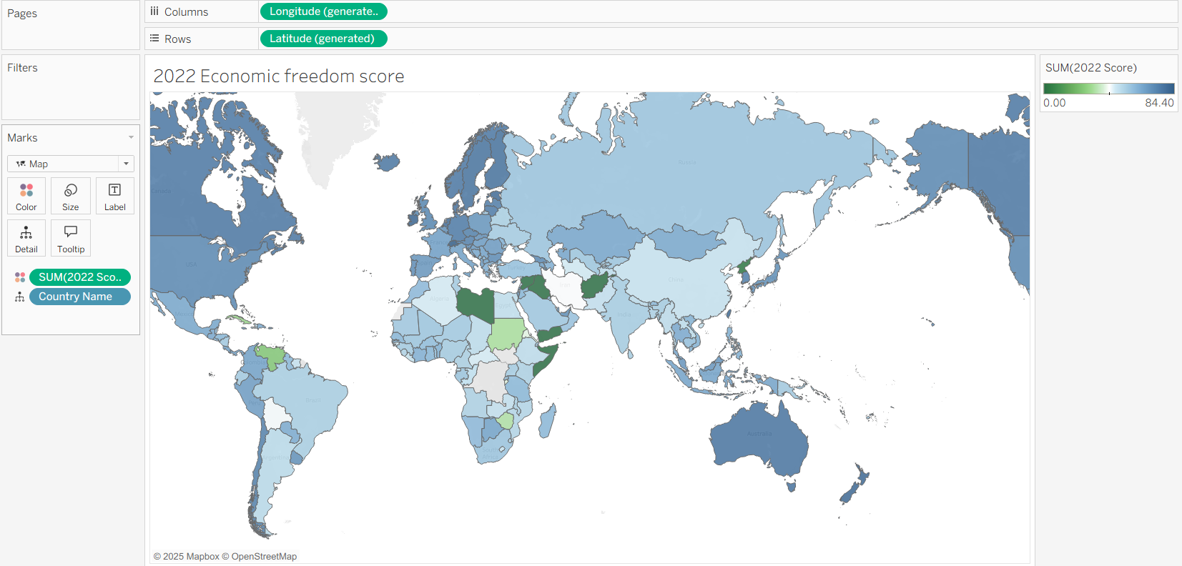

**Top 40 ranking countries in the index**

This Map demonstrates the top 40 ranking countries according to the 2022 economic freedom index

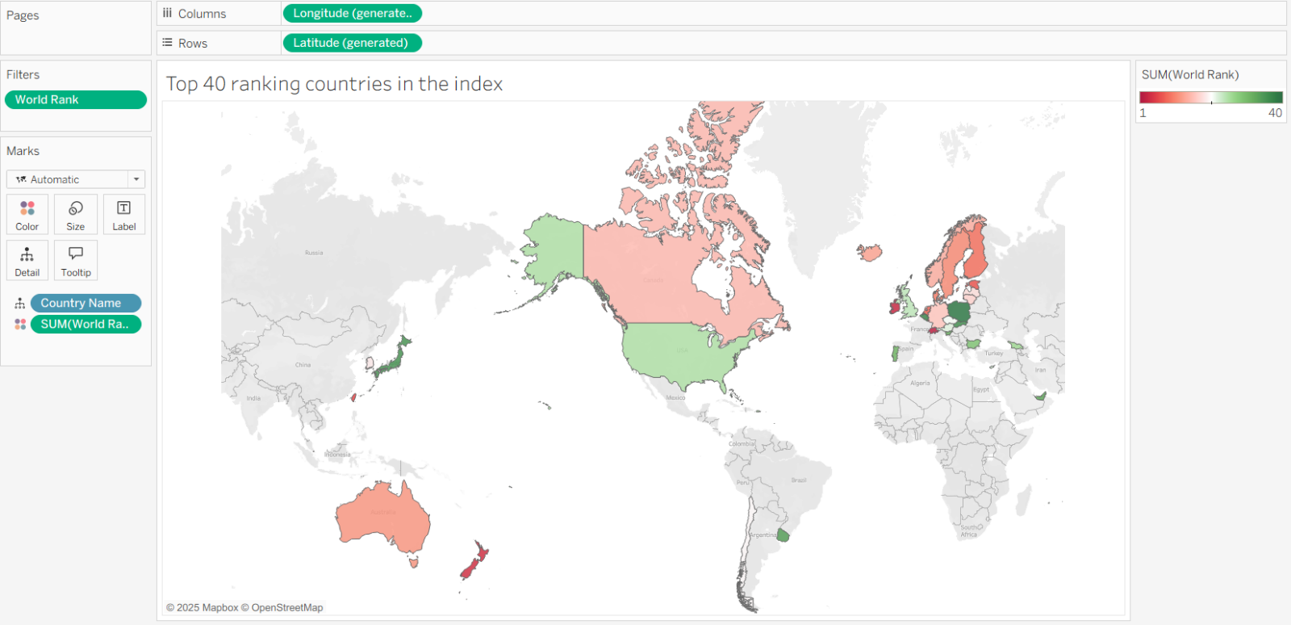

**Bottom ranking countries in the index**

This map demonstrates the bottom ranking countries according to the 2022 economic index freedom

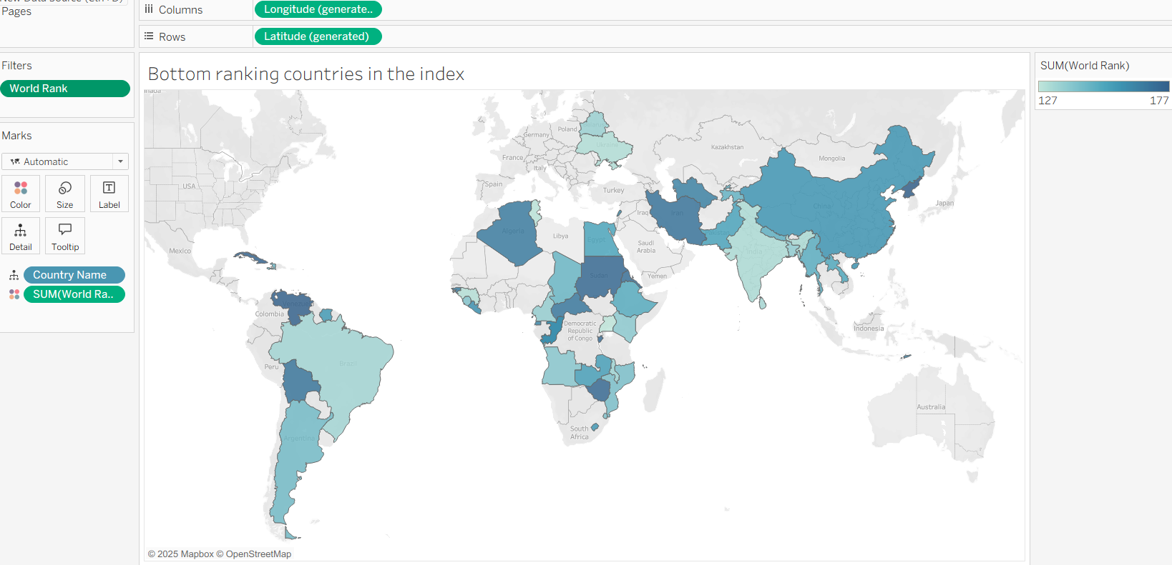

**Index score based on unemployment rate**

This column chart demonstrates the unemployment across different countries and its effect on the final index score

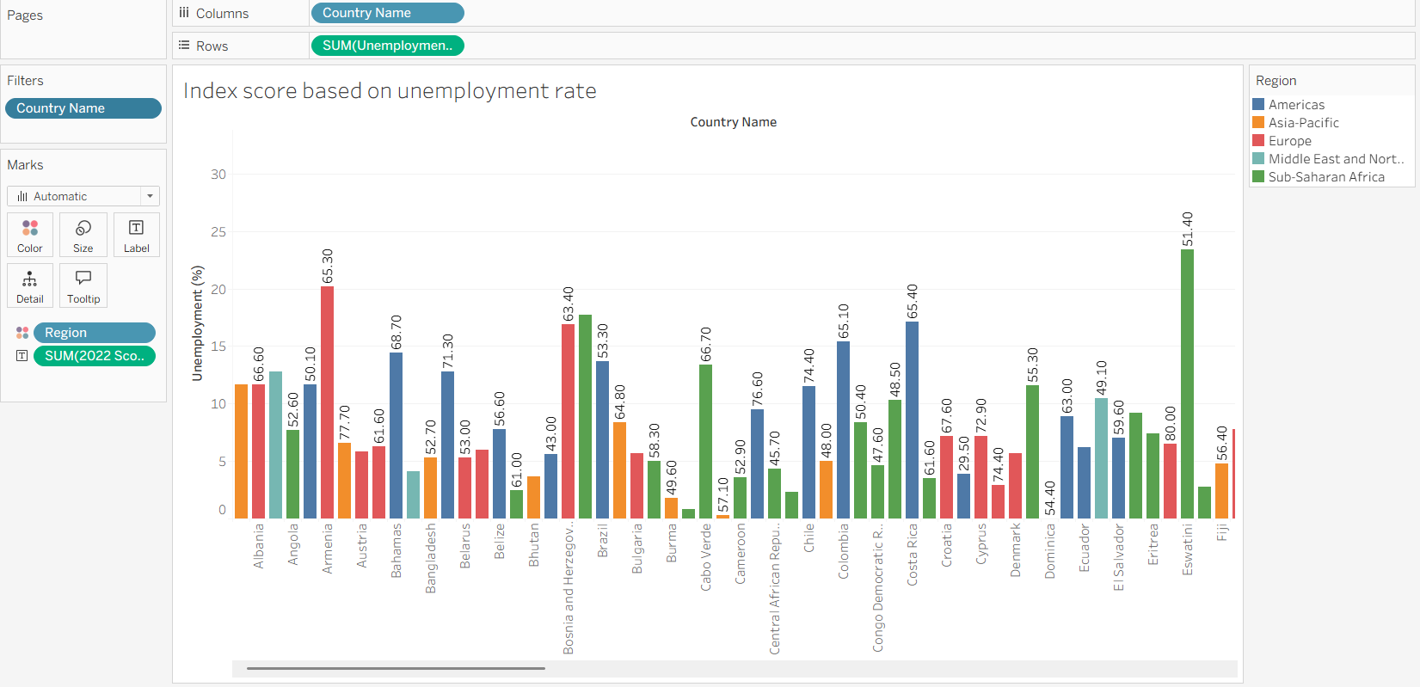

**Index score based on financial freedom**

This treemap demonstrates the effect of financial freedom on the index score. we can see from the map that, countries in sub-saharan africa have lesser extent of financial freedom

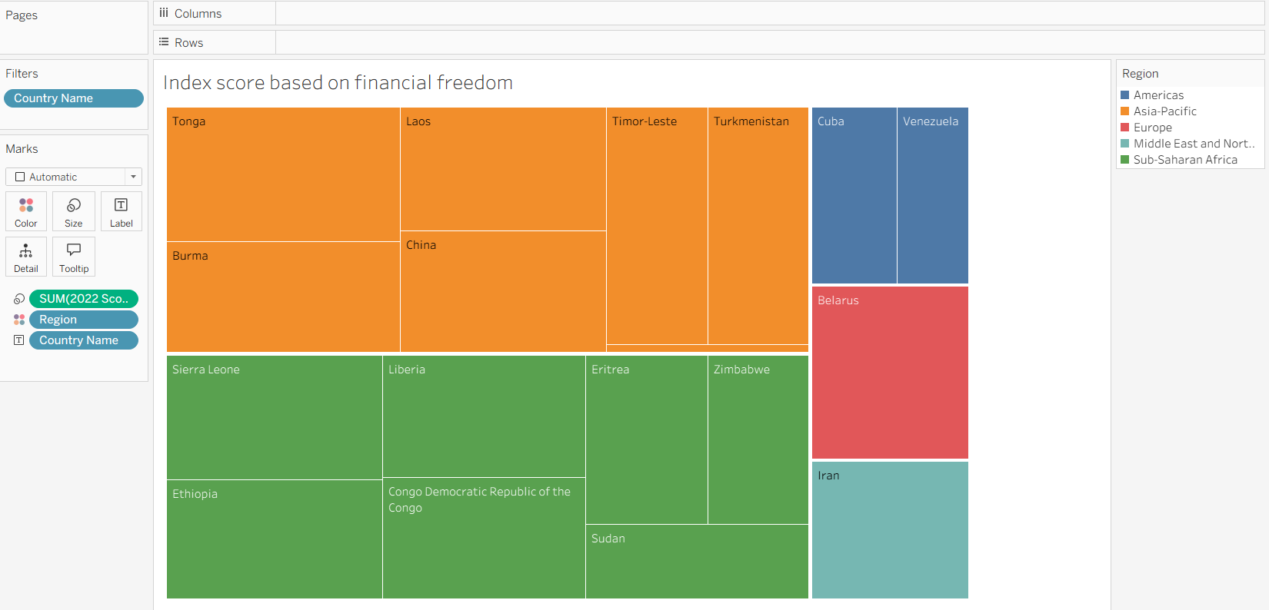

**Index score based on population**

This horizontal bar chart demonstrates if population of a country is in anyway affecting the final index score of a country

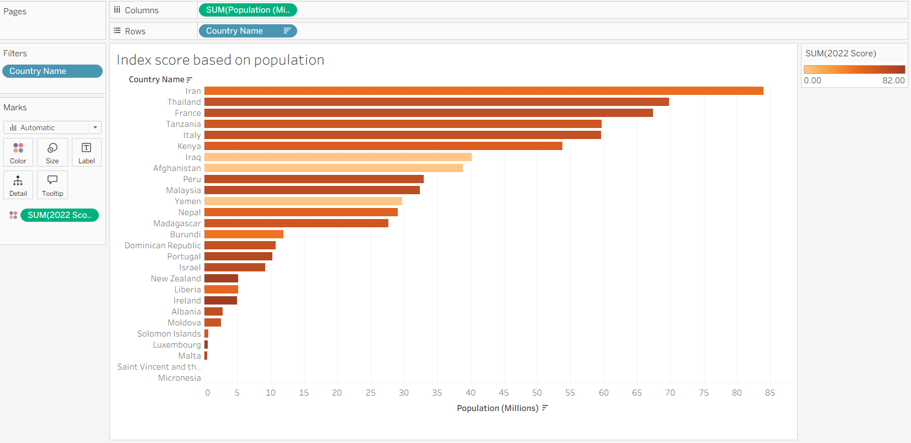

**Index score based on 5 year on GDP growth rate(%)**

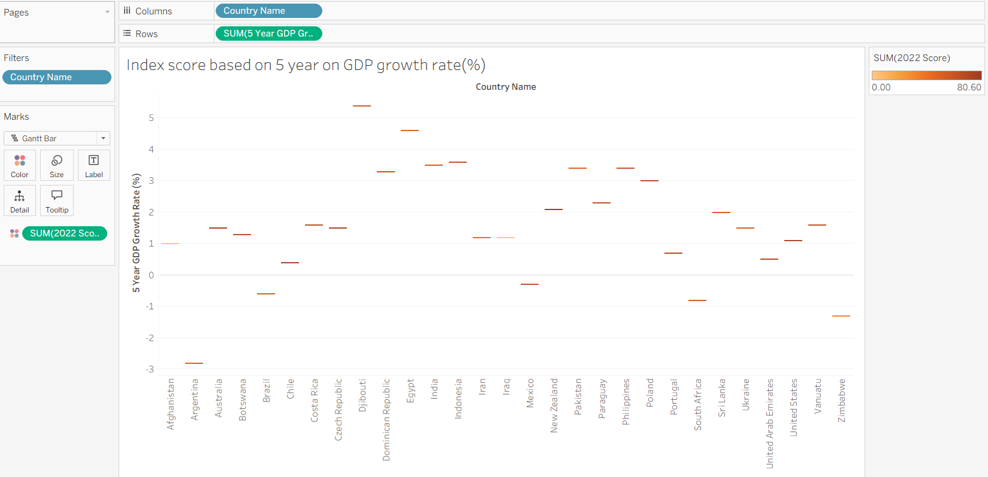

**Inflation rate in different countries**

This area chart describes the effect of inflation on final standing of a country.as we can see, venezuela has the worst inflation in the world.

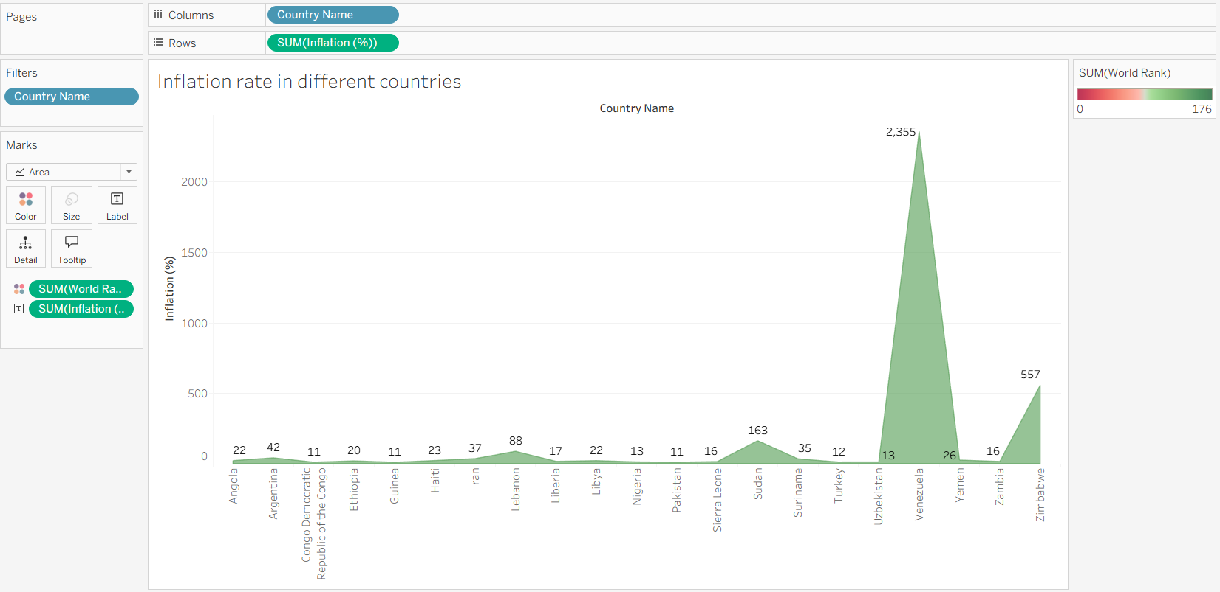

**Correlation between inflation and unemployment**

This line graph demonstrates the correlation between inflation and unemployment. we observe from the graph that, inflation and unemployment are closely related

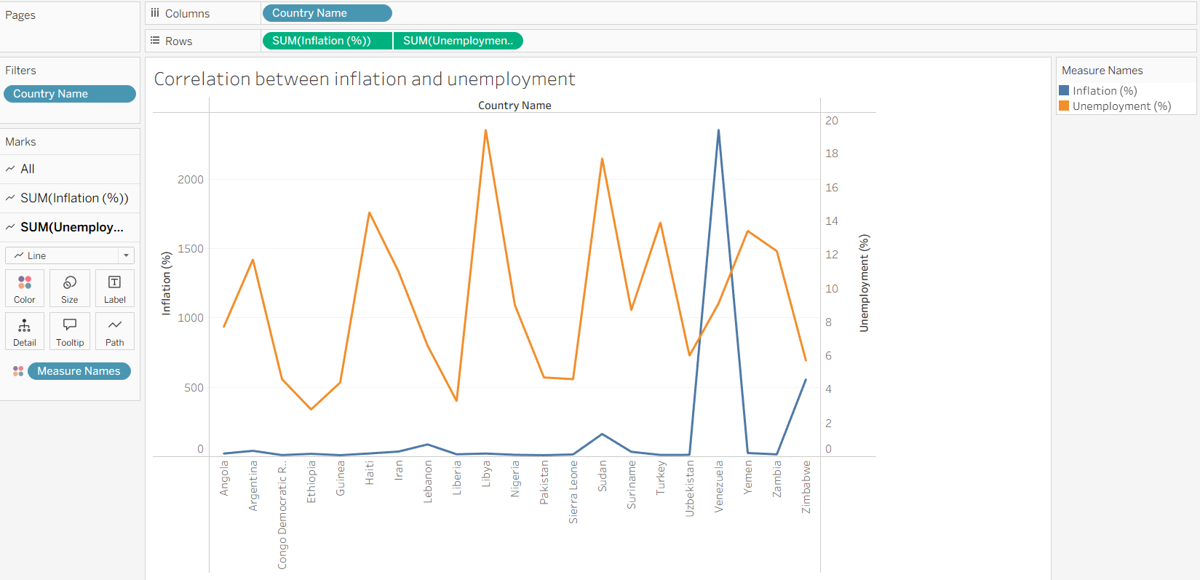

**Correlation between GDP(PPP) and monetary freedom**

This line graph demonstrates the correlation between GDP per capita (PPP) and monetary freedom of a country

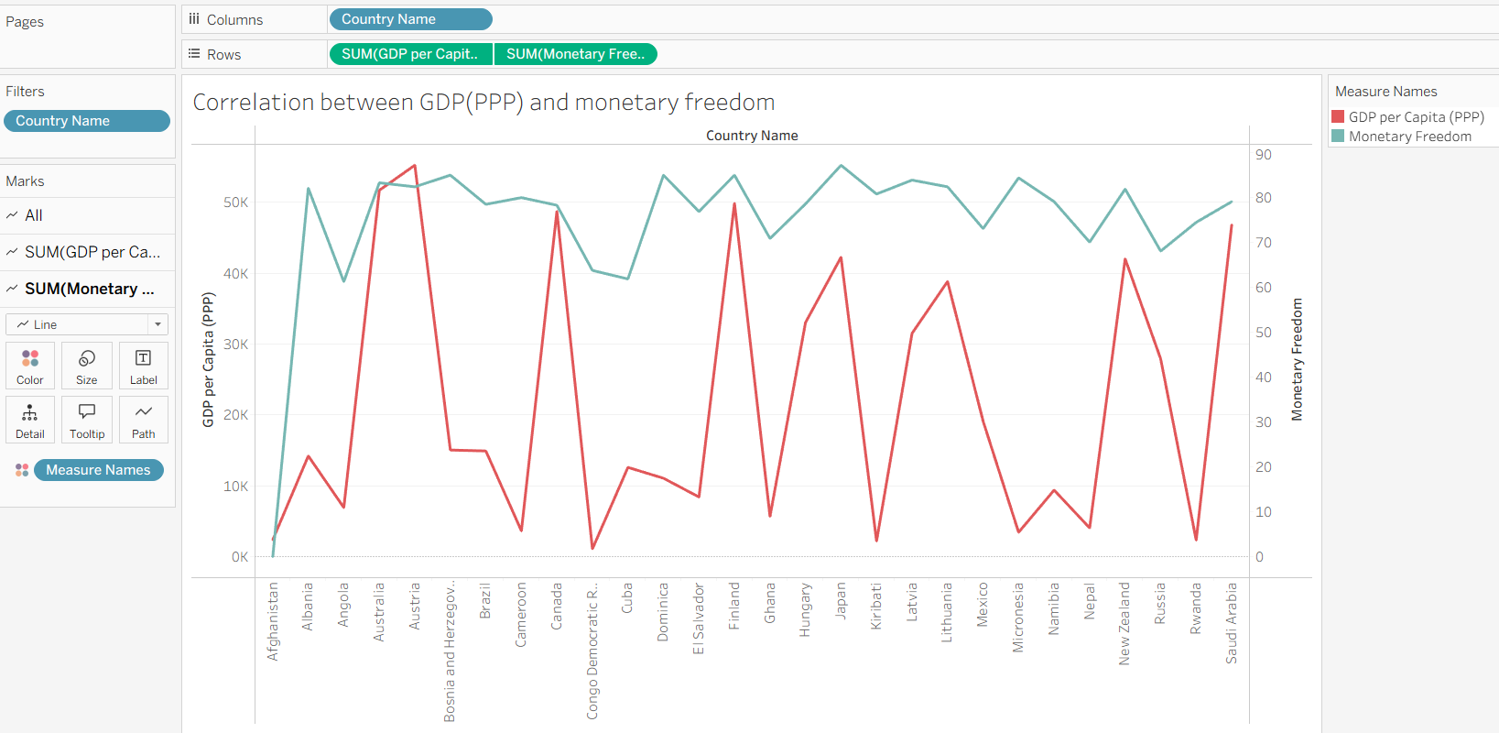

**Top 40 countries by GDP growth rate**

This chart demonstrates the GDP growth rate of different countries, and the effect of it on their final rank

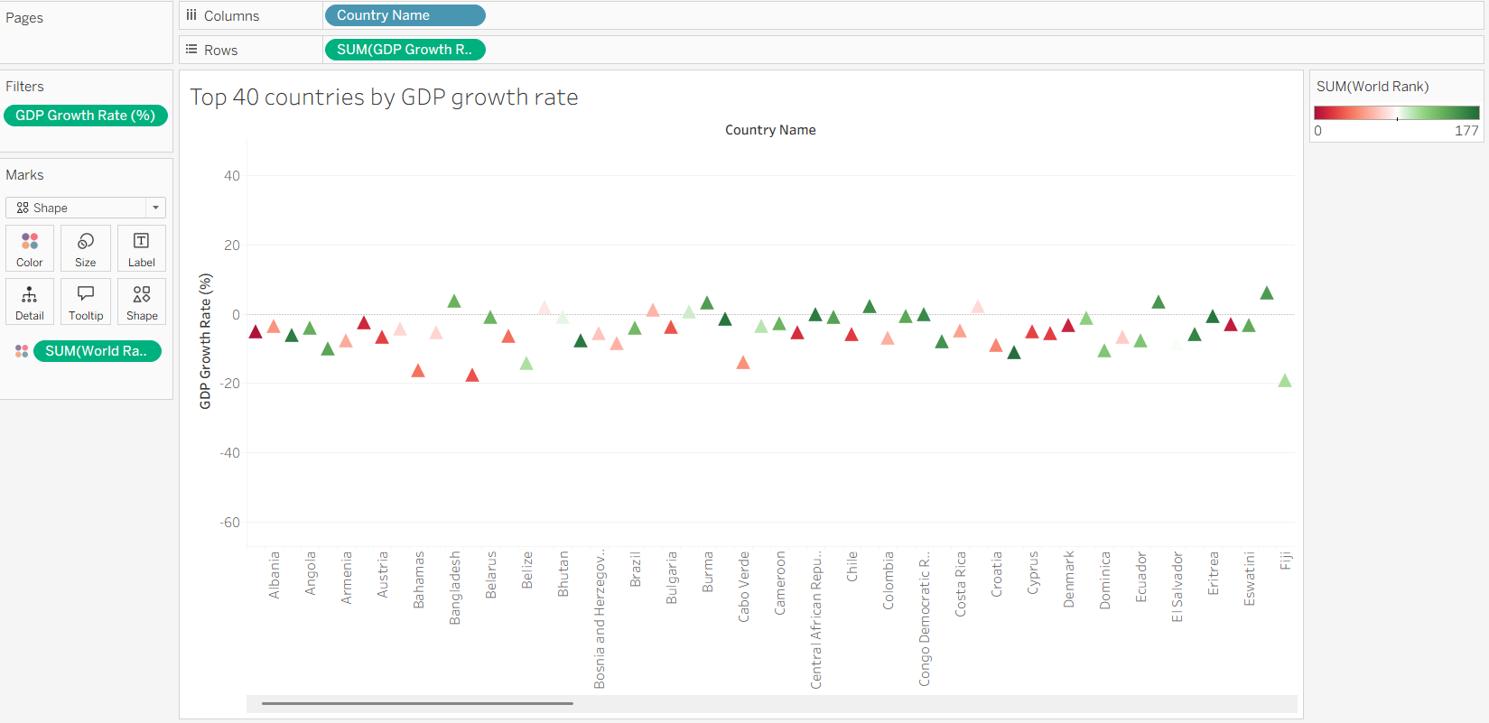

**Dashboard**

Dashboard can be defined as an information management tool that visually tracks, analyses, and displays key performance indicators (KPI), metrics, as well as key data points, allowing you to monitor the current state of your business, department, team, or specific process.

**Dashboard 1:**

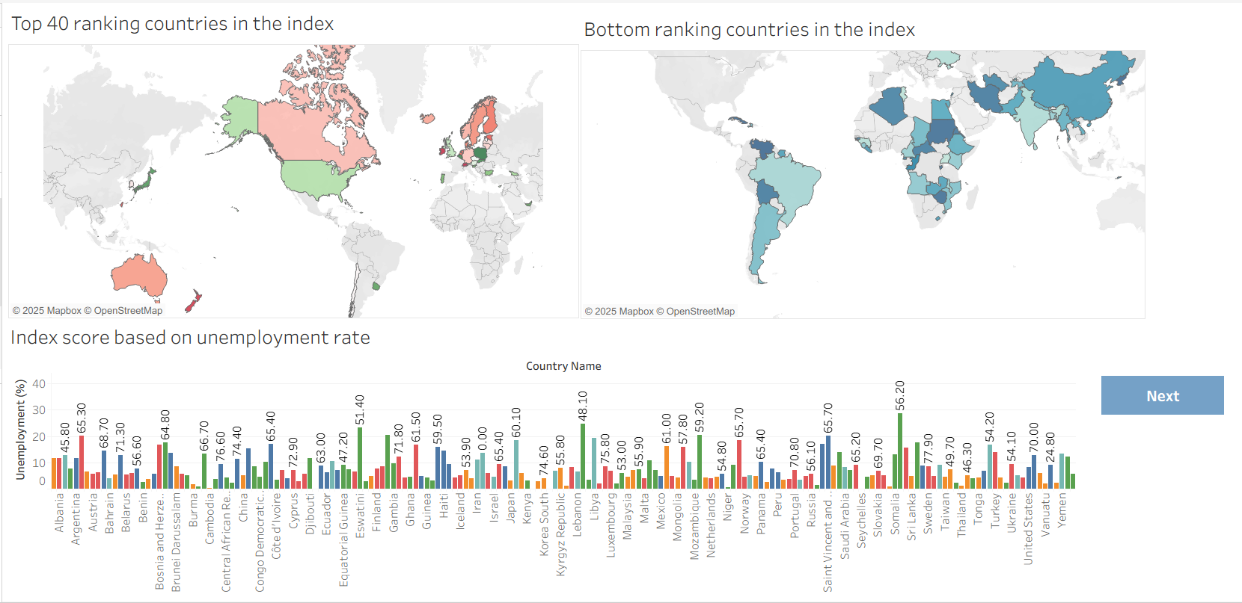

**Dashboard 2:**

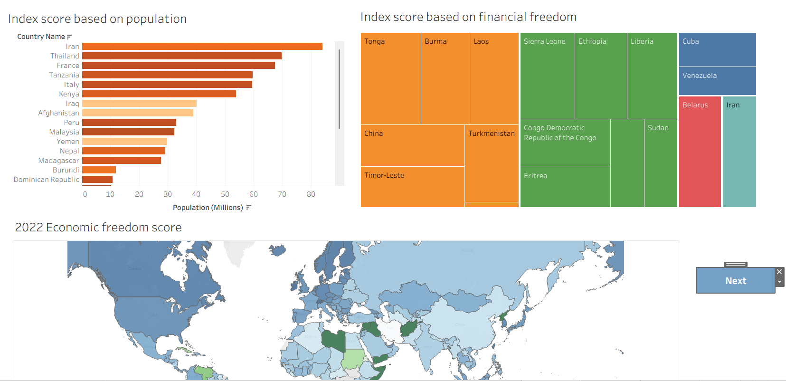

**Dashboard 3:**

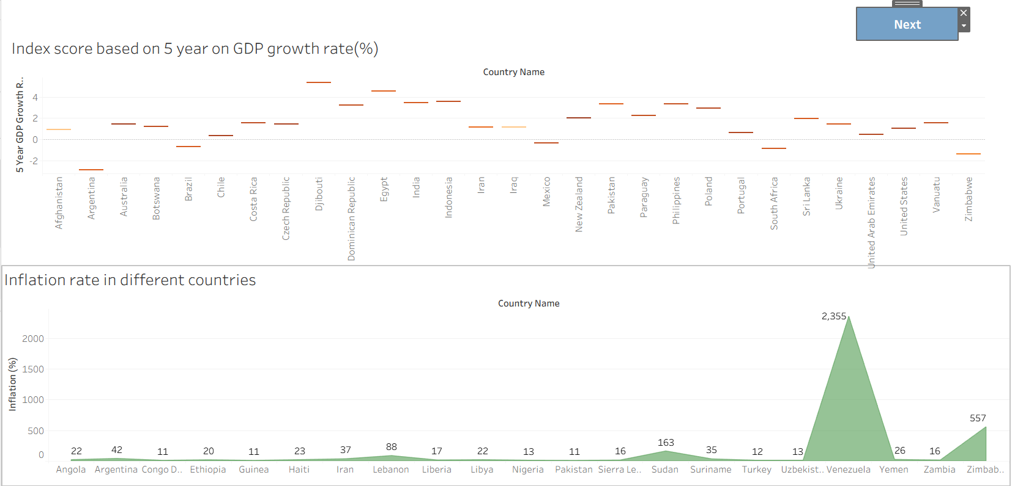

**Dashboard 4:**

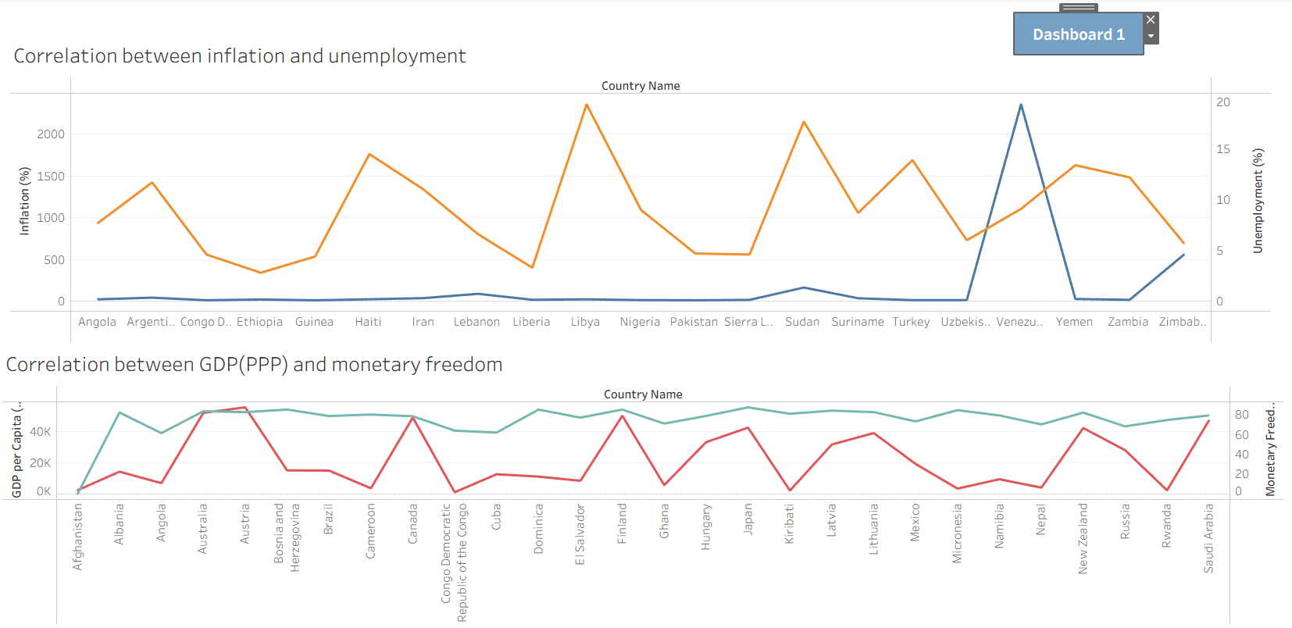

**Story**

A data story is a way of presenting data and analysis in a narrative format, with the goal of making the information more engaging and easier to understand. A data story typically includes a clear introduction that sets the stage and explains the context for the data, a body that presents the data and analysis in a logical and systematic way, and a conclusion that summarizes the key findings and highlights their

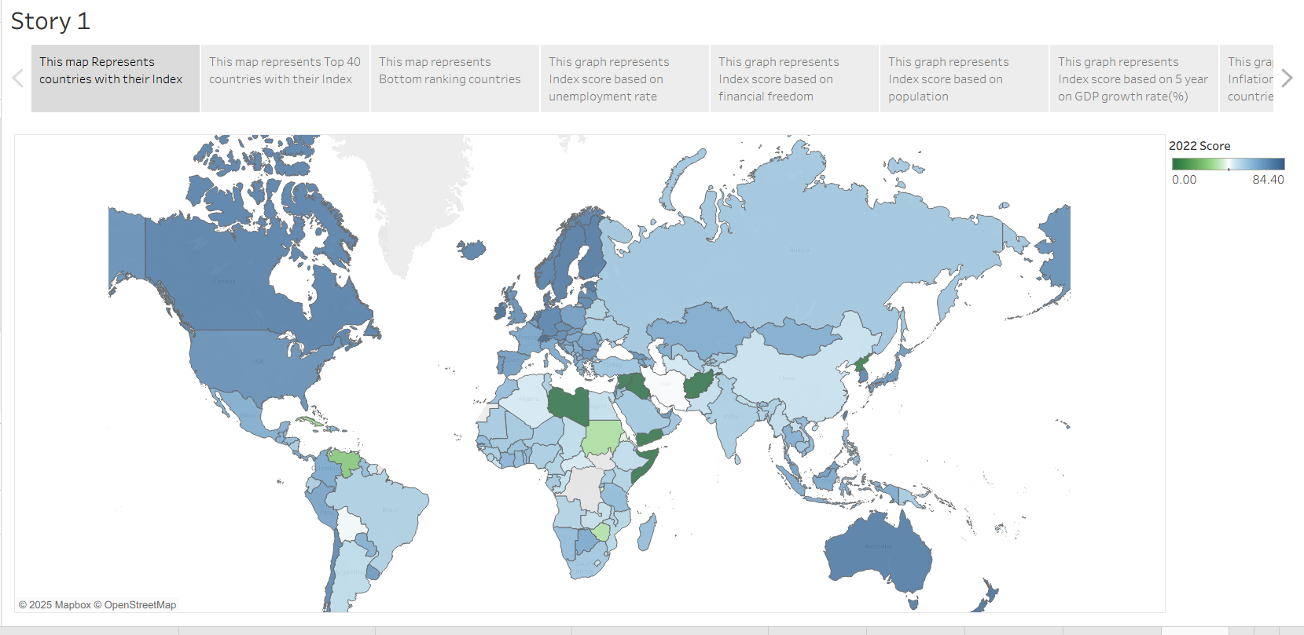

**Web integration**

**App.py:**

from flask import Flask, render_template, request

app = Flask(__name__)

@app.route("/")

def hello_world():

    return render_template('index.html')

if __name__ == '__main__':

    app.run(debug=False)

**index.html:**

<!DOCTYPE html>

<html lang="en">

<head>

  <meta charset="utf-8">

  <meta content="width=device-width, initial-scale=1.0" name="viewport">

  <title>Electricity consumption analysis</title>

  <meta name="description" content="">

  <meta name="keywords" content="">

  <!-- Favicons -->

  <link href="/static/img/favicon.png" rel="icon">

  <link href="/static/img/apple-touch-icon.png" rel="apple-touch-icon">

  <!-- Fonts -->

  <link href="https://fonts.googleapis.com" rel="preconnect">

  <link href="https://fonts.g/static.com" rel="preconnect" crossorigin>

  <link href="https://fonts.googleapis.com/css2?family=Roboto:ital,wght@0,100;0,300;0,400;0,500;0,700;0,900;1,100;1,300;1,400;1,500;1,700;1,900&family=Poppins:ital,wght@0,100;0,200;0,300;0,400;0,500;0,600;0,700;0,800;0,900;1,100;1,200;1,300;1,400;1,500;1,600;1,700;1,800;1,900&family=Raleway:ital,wght@0,100;0,200;0,300;0,400;0,500;0,600;0,700;0,800;0,900;1,100;1,200;1,300;1,400;1,500;1,600;1,700;1,800;1,900&display=swap" rel="stylesheet">

  <!-- Vendor CSS Files -->

  <link href="/static/vendor/bootstrap/css/bootstrap.min.css" rel="stylesheet">

  <link href="/static/vendor/bootstrap-icons/bootstrap-icons.css" rel="stylesheet">

  <link href="/static/vendor/aos/aos.css" rel="stylesheet">

  <link href="/static/vendor/glightbox/css/glightbox.min.css" rel="stylesheet">

  <link href="/static/vendor/swiper/swiper-bundle.min.css" rel="stylesheet">

  <!-- Main CSS File -->

  <link href="/static/css/main.css" rel="stylesheet">

</head>

<body class="index-page">

  <header id="header" class="header d-flex align-items-center fixed-top">

    <div class="container-fluid container-xl position-relative d-flex align-items-center justify-content-between">

      <a href="index.html" class="logo d-flex align-items-center">

        <!-- Uncomment the line below if you also wish to use an image logo -->

        <!-- <img src="/static/img/logo.png" alt=""> -->

      </a>

      <nav id="navmenu" class="navmenu">

        <ul>

          <li><a href="#hero" class="active">Home</a></li>

          <li><a href="#about">About</a></li>

          <li><a href="#services">Story</a></li>

          <li><a href="#portfolio">Dashboard</a></li>

          <li><a href="#team">Visualizations</a></li>

        </ul>

        <i class="mobile-nav-toggle d-xl-none bi bi-list"></i>

      </nav>

    </div>

  </header>

  <main class="main">

    <!-- Hero Section -->

    <section id="hero" class="hero section accent-background">

          <img src="/static/img/hero-bg.png" alt="" data-aos="fade-in">

      <div class="container text-center" data-aos="fade-up" data-aos-delay="100">

        <h2>WELCOME TO ECONOMIC FREEDOM INDEX</h2>

        <p>ANALYSIS OF GLOBAL ECONOMIC FREEDOM (2022)

</p>

        <a href="#about" class="btn-scroll" title="Scroll Down"><i class="bi bi-chevron-down"></i></a>

      </div>

    </section><!-- /Hero Section -->

    <!-- About Section -->

    <section id="about" class="about section">

      <div class="container">

        <div class="row gy-5">

          <div class="content col-xl-5 d-flex flex-column" data-aos="fade-up" data-aos-delay="100">

            <h3>Economic Freedom Insights & Trends</h3>

            <p>

              The Index of Economic Freedom reveals how nations perform in terms of personal choice, voluntary exchange, freedom to compete, and security of privately owned property. This analysis highlights key global trends across governance, markets, and regulatory environments.

            </p>

          </div>

          <div class="col-xl-7" data-aos="fade-up" data-aos-delay="200">

            <div class="row gy-4">

              <div class="col-md-6 icon-box position-relative">

                <h4><a href="" class="stretched-link">Rule of Law Analysis</a></h4>

                <p>Explore how property rights, judicial effectiveness, and government integrity influence national economic freedom scores.</p>

              </div><!-- Icon-Box -->

              <div class="col-md-6 icon-box position-relative">

                <h4><a href="" class="stretched-link">Government Size & Spending</a></h4>

                <p>Examine the impact of government expenditures, taxation levels, and fiscal health on overall economic freedom.</p>

              </div><!-- Icon-Box -->

              <div class="col-md-6 icon-box position-relative">

                <h4><a href="" class="stretched-link">Regulatory Efficiency</a></h4>

                <p>Understand the business, labor, and monetary regulations that enhance or hinder a country’s market performance.</p>

              </div><!-- Icon-Box -->

              <div class="col-md-6 icon-box position-relative">

                <h4><a href="" class="stretched-link">Open Markets Impact</a></h4>

                <p>Assess how trade freedom, investment freedom, and financial openness contribute to national prosperity and growth.</p>

              </div><!-- Icon-Box -->

            </div>

          </div>

        </div>

      </div>

    </section><!-- /About Section -->

    <!-- Services Section -->

    <section id="services" class="services section">

      <!-- Section Title -->

      <div class="container section-title" data-aos="fade-up">

        <h2>Story</h2>

      </div><!-- End Section Title -->

      <div class='tableauPlaceholder' id='viz1750925296677' style='position: relative'>

        <noscript>

          <a href='#'>

            <img alt='Story 1 ' src='https:&#47;&#47;public.tableau.com&#47;static&#47;images&#47;Ec&#47;EconomicFreedomAnalysisstory&#47;Story1&#47;1_rss.png' style='border: none' />

          </a>

        </noscript>

        <object class='tableauViz'  style='display:none;'>

          <param name='host_url' value='https%3A%2F%2Fpublic.tableau.com%2F' />

          <param name='embed_code_version' value='3' />

          <param name='site_root' value='' />

          <param name='name' value='EconomicFreedomAnalysisstory&#47;Story1' />

          <param name='tabs' value='no' />

          <param name='toolbar' value='yes' />

          <param name='static_image' value='https:&#47;&#47;public.tableau.com&#47;static&#47;images&#47;Ec&#47;EconomicFreedomAnalysisstory&#47;Story1&#47;1.png' />

          <param name='animate_transition' value='yes' />

          <param name='display_static_image' value='yes' />

          <param name='display_spinner' value='yes' />

          <param name='display_overlay' value='yes' />

          <param name='display_count' value='yes' />

          <param name='language' value='en-US' />

          <param name='filter' value='publish=yes' />

        </object>

      </div>

      <script type='text/javascript'>

        var divElement = document.getElementById('viz1750925296677');

        var vizElement = divElement.getElementsByTagName('object')[0];

        vizElement.style.width='100%';

        vizElement.style.height=(divElement.offsetWidth*0.75)+'px';

        var scriptElement = document.createElement('script');

        scriptElement.src = 'https://public.tableau.com/javascripts/api/viz_v1.js';

        vizElement.parentNode.insertBefore(scriptElement, vizElement);

      </script>

    </section><!-- /Services Section -->

    <!-- Portfolio Section -->

    <section id="portfolio" class="portfolio section">

      <!-- Section Title -->

      <div class="container section-title" data-aos="fade-up">

        <h2>Dashboard</h2>

        <p>Visualize and analyze economic freedom metrics for 176 countries in 2022 — explore interactive dashboards featuring key indicators like fiscal health, trade freedom, inflation, unemployment, and GDP growth. Identify patterns, correlations, and global trends through engaging charts and maps.</p>

      </div><!-- End Section Title -->

      <div class='tableauPlaceholder' id='viz1750925662385' style='position: relative'>

        <noscript>

          <a href='#'>

            <img alt='Dashboard 1 ' src='https:&#47;&#47;public.tableau.com&#47;static&#47;images&#47;Ec&#47;EconomicFreedomAnalysis_17509227136340&#47;Dashboard1&#47;1_rss.png' style='border: none' />

          </a>

        </noscript>

        <object class='tableauViz'  style='display:none;'>

          <param name='host_url' value='https%3A%2F%2Fpublic.tableau.com%2F' />

          <param name='embed_code_version' value='3' />

          <param name='site_root' value='' />

          <param name='name' value='EconomicFreedomAnalysis_17509227136340&#47;Dashboard1' />

          <param name='tabs' value='no' />

          <param name='toolbar' value='yes' />

          <param name='static_image' value='https:&#47;&#47;public.tableau.com&#47;static&#47;images&#47;Ec&#47;EconomicFreedomAnalysis_17509227136340&#47;Dashboard1&#47;1.png' />

          <param name='animate_transition' value='yes' />

          <param name='display_static_image' value='yes' />

          <param name='display_spinner' value='yes' />

          <param name='display_overlay' value='yes' />

          <param name='display_count' value='yes' />

          <param name='language' value='en-US' />

          <param name='filter' value='publish=yes' />

        </object>

      </div>

      <script type='text/javascript'>

      var divElement = document.getElementById('viz1750925662385');

      var vizElement = divElement.getElementsByTagName('object')[0];

      if ( divElement.offsetWidth > 800 )

      {

        vizElement.style.width='100%';

        vizElement.style.height=(divElement.offsetWidth*0.75)+'px';

        }

      else if ( divElement.offsetWidth > 500 )

      {

        vizElement.style.width='100%';

        vizElement.style.height=(divElement.offsetWidth*0.75)+'px';

        }

      else

      {

        vizElement.style.width='100%';

        vizElement.style.height='977px';

      }

      var scriptElement = document.createElement('script');

      scriptElement.src = 'https://public.tableau.com/javascripts/api/viz_v1.js';

      vizElement.parentNode.insertBefore(scriptElement, vizElement);

      </script>

    </section><!-- /Portfolio Section -->

    <!-- Team Section -->

    <section id="team" class="team section">

      <!-- Section Title -->

      <div class="container section-title" data-aos="fade-up">

        <h2>Visualizations</h2>

        <p>Explore interactive maps, bar charts, treemaps, and line graphs that illustrate global patterns in economic freedom. Visuals cover key factors like inflation, unemployment, financial freedom, GDP growth, and their combined influence on national index scores.</p>

      </div><!-- End Section Title -->

      <div class="container" data-aos="fade-up" data-aos-delay="100">

        <div class="row gy-5">

          <div class="col-xl-4 col-md-6 d-flex" data-aos="zoom-in" data-aos-delay="200">

            <div class="team-member">

              <div class="member-img">

                <img src="/static/img/team/2022 Economic freedom score.png" class="img-fluid" alt="">

              </div>

              <div class="member-info">

                 <h4>2022 Economic Freedom Score</h4>

              </div>

            </div>

          </div><!-- End Team Member -->

          <div class="col-xl-4 col-md-6 d-flex" data-aos="zoom-in" data-aos-delay="400">

            <div class="team-member">

              <div class="member-img">

                <img src="/static/img/team/Top 40 ranking countries in the the index.png" class="img-fluid" alt="">

              </div>

              <div class="member-info">

                <h4>Top 40 Ranking Countries in the Index</h4>

              </div>

            </div>

          </div><!-- End Team Member -->

          <div class="col-xl-4 col-md-6 d-flex" data-aos="zoom-in" data-aos-delay="600">

          <div class="team-member">

            <div class="member-img">

              <img src="/static/img/team/Bottom ranking countries in the index.png" class="img-fluid" alt="">

            </div>

            <div class="member-info">

              <h4>Bottom Ranking Countries in the Index</h4>

            </div>

          </div>

        </div><!-- End Team Member -->

        <div class="col-xl-4 col-md-6 d-flex" data-aos="zoom-in" data-aos-delay="200">

          <div class="team-member">

            <div class="member-img">

              <img src="/static/img/team/Index score based on unemployment rate.png" class="img-fluid" alt="">

            </div>

            <div class="member-info">

              <h4>Index Score Based on Unemployment Rate</h4>

            </div>

          </div>

        </div><!-- End Team Member -->

          <div class="col-xl-4 col-md-6 d-flex" data-aos="zoom-in" data-aos-delay="400">

            <div class="team-member">

              <div class="member-img">

                <img src="/static/img/team/Index score based on financial freedom.png" class="img-fluid" alt="">

              </div>

              <div class="member-info">

                <h4>Index Score Based on Financial Freedom</h4>

              </div>

            </div>

          </div><!-- End Team Member -->

        <div class="col-xl-4 col-md-6 d-flex" data-aos="zoom-in" data-aos-delay="600">

          <div class="team-member">

            <div class="member-img">

              <img src="/static/img/team/Index score based on population.png" class="img-fluid" alt="">

            </div>

            <div class="member-info">

              <h4>Index Score Based on Population</h4>

            </div>

          </div>

        </div><!-- End Team Member -->

        <div class="col-xl-4 col-md-6 d-flex" data-aos="zoom-in" data-aos-delay="200">

          <div class="team-member">

            <div class="member-img">

              <img src="/static/img/team/Inflation rate in different countries.png" class="img-fluid" alt="">

            </div>

            <div class="member-info">

              <h4>Inflation Rate in Different Countries</h4>

            </div>

          </div>

        </div><!-- End Team Member -->

        <div class="col-xl-4 col-md-6 d-flex" data-aos="zoom-in" data-aos-delay="400">

          <div class="team-member">

            <div class="member-img">

              <img src="/static/img/team/Correlation between inflation and unemployment.png" class="img-fluid" alt="">

            </div>

            <div class="member-info">

              <h4>Correlation Between Inflation and Unemployment</h4>

            </div>

          </div>

        </div><!-- End Team Member -->

        <div class="col-xl-4 col-md-6 d-flex" data-aos="zoom-in" data-aos-delay="600">

          <div class="team-member">

            <div class="member-img">

              <img src="/static/img/team/Correlation Between GDP(PPP) and monetary freedom.png" class="img-fluid" alt="">

            </div>

            <div class="member-info">

              <h4>Correlation Between GDP(PPP) and Monetary Freedom</h4>

            </div>

          </div>

        </div><!-- End Team Member -->

        <div class="col-xl-4 col-md-6 d-flex" data-aos="zoom-in" data-aos-delay="200">

          <div class="team-member">

            <div class="member-img">

              <img src="/static/img/team/Top 40 countries by GDP growth rate.png" class="img-fluid" alt="">

            </div>

            <div class="member-info">

              <h4>Top 40 Countries by GDP Growth Rate</h4>

            </div>

          </div>

        </div><!-- End Team Member -->

      </div>

    </main>

  <!-- Scroll Top -->

  <a href="#" id="scroll-top" class="scroll-top d-flex align-items-center justify-content-center"><i class="bi bi-arrow-up-short"></i></a>

  <!-- Preloader -->

  <div id="preloader"></div>

  <!-- Vendor JS Files -->

  <script src="/static/vendor/bootstrap/js/bootstrap.bundle.min.js"></script>

  <script src="/static/vendor/php-email-form/validate.js"></script>

  <script src="/static/vendor/aos/aos.js"></script>

  <script src="/static/vendor/purecounter/purecounter_vanilla.js"></script>

  <script src="/static/vendor/glightbox/js/glightbox.min.js"></script>

  <script src="/static/vendor/imagesloaded/imagesloaded.pkgd.min.js"></script>

  <script src="/static/vendor/isotope-layout/isotope.pkgd.min.js"></script>

  <script src="/static/vendor/swiper/swiper-bundle.min.js"></script>

  <!-- Main JS File -->

  <script src="/static/js/main.js"></script>

</body>

</html>

**Main.css:**

:root {

  --default-font: "Roboto",  system-ui, -apple-system, "Segoe UI", Roboto, "Helvetica Neue", Arial, "Noto Sans", "Liberation Sans", sans-serif, "Apple Color Emoji", "Segoe UI Emoji", "Segoe UI Symbol", "Noto Color Emoji";

  --heading-font: "Raleway",  sans-serif;

  --nav-font: "Poppins",  sans-serif;

}

/* Global Colors - The following color variables are used throughout the website. Updating them here will change the color scheme of the entire website */

:root {

  --background-color: #ffffff; /* Background color for the entire website, including individual sections */

  --default-color: #444444; /* Default color used for the majority of the text content across the entire website */

  --heading-color: #2f4d5a; /* Color for headings, subheadings and title throughout the website */

  --accent-color: #67b0d1; /* Accent color that represents your brand on the website. It's used for buttons, links, and other elements that need to stand out */

  --surface-color: #ffffff; /* The surface color is used as a background of boxed elements within sections, such as cards, icon boxes, or other elements that require a visual separation from the global background. */

  --contrast-color: #ffffff; /* Contrast color for text, ensuring readability against backgrounds of accent, heading, or default colors. */

}

/* Nav Menu Colors - The following color variables are used specifically for the navigation menu. They are separate from the global colors to allow for more customization options */

:root {

  --nav-color: #ffffff;  /* The default color of the main navmenu links */

  --nav-hover-color: #67b0d1; /* Applied to main navmenu links when they are hovered over or active */

  --nav-mobile-background-color: #ffffff; /* Used as the background color for mobile navigation menu */

  --nav-dropdown-background-color: #ffffff; /* Used as the background color for dropdown items that appear when hovering over primary navigation items */

  --nav-dropdown-color: #444444; /* Used for navigation links of the dropdown items in the navigation menu. */

  --nav-dropdown-hover-color: #67b0d1; /* Similar to --nav-hover-color, this color is applied to dropdown navigation links when they are hovered over. */

}

/* Color Presets - These classes override global colors when applied to any section or element, providing reuse of the sam color scheme. */

.light-background {

  --background-color: #f5f9fc;

  --surface-color: #ffffff;

}

.dark-background {

  --background-color: #273f49;

  --default-color: #ffffff;

  --heading-color: #ffffff;

  --surface-color: #395c6a;

  --contrast-color: #ffffff;

}

.accent-background {

  --background-color: #67b0d1;

  --default-color: #ffffff;

  --heading-color: #ffffff;

  --surface-color: #8ec4dd;

}

/* Smooth scroll */

:root {

  scroll-behavior: smooth;

}

/*--------------------------------------------------------------

# General Styling & Shared Classes

--------------------------------------------------------------*/

body {

  color: var(--default-color);

  background-color: var(--background-color);

  font-family: var(--default-font);

}

a {

  color: var(--accent-color);

  text-decoration: none;

  transition: 0.3s;

}

a:hover {

  color: color-mix(in srgb, var(--accent-color), transparent 25%);

  text-decoration: none;

}

h1,

h2,

h3,

h4,

h5,

h6 {

  color: var(--heading-color);

  font-family: var(--heading-font);

}

/* PHP Email Form Messages

------------------------------*/

.php-email-form .error-message {

  display: none;

  background: #df1529;

  color: #ffffff;

  text-align: left;

  padding: 15px;

  margin-bottom: 24px;

  font-weight: 600;

}

.php-email-form .sent-message {

  display: none;

  color: #ffffff;

  background: #059652;

  text-align: center;

  padding: 15px;

  margin-bottom: 24px;

  font-weight: 600;

}

.php-email-form .loading {

  display: none;

  background: var(--surface-color);

  text-align: center;

  padding: 15px;

  margin-bottom: 24px;

}

.php-email-form .loading:before {

  content: "";

  display: inline-block;

  border-radius: 50%;

  width: 24px;

  height: 24px;

  margin: 0 10px -6px 0;

  border: 3px solid var(--accent-color);

  border-top-color: var(--surface-color);

  animation: php-email-form-loading 1s linear infinite;

}

@keyframes php-email-form-loading {

  0% {

    transform: rotate(0deg);

  }

  100% {

    transform: rotate(360deg);

  }

}

/*--------------------------------------------------------------

# Global Header

--------------------------------------------------------------*/

.header {

  --background-color: rgba(255, 255, 255, 0);

  --default-color: #ffffff;

  --heading-color: #ffffff;

  color: var(--default-color);

  background-color: var(--background-color);

  padding: 15px 0;

  transition: all 0.5s;

  z-index: 997;

}

.header .logo {

  line-height: 1;

}

.header .logo img {

  max-height: 32px;

  margin-right: 8px;

}

.header .logo h1 {

  font-size: 26px;

  margin: 0;

  font-weight: 700;

  color: var(--heading-color);

  text-transform: uppercase;

}

.scrolled .header {

  box-shadow: 0px 0 18px rgba(0, 0, 0, 0.1);

}

/* Global Header on Scroll

------------------------------*/

.scrolled .header {

  --background-color: #4b99bb;

}

/*--------------------------------------------------------------

# Navigation Menu

--------------------------------------------------------------*/

/* Desktop Navigation */

@media (min-width: 1200px) {

  .navmenu {

    padding: 0;

  }

  .navmenu ul {

    margin: 0;

    padding: 0;

    display: flex;

    list-style: none;

    align-items: center;

  }

  .navmenu li {

    position: relative;

  }

  .navmenu a,

  .navmenu a:focus {

    color: var(--nav-color);

    padding: 10px 15px;

    margin-left: 2px;

    font-size: 16px;

    font-family: var(--nav-font);

    font-weight: 500;

    display: flex;

    align-items: center;

    justify-content: space-between;

    white-space: nowrap;

    transition: 0.3s;

  }

  .navmenu a i,

  .navmenu a:focus i {

    font-size: 12px;

    line-height: 0;

    margin-left: 5px;

    transition: 0.3s;

  }

  .navmenu li:hover>a,

  .navmenu .active,

  .navmenu .active:focus {

    color: var(--contrast-color);

    background-color: var(--nav-hover-color);

  }

  .navmenu .dropdown ul {

    margin: 0;

    padding: 0;

    background: var(--nav-dropdown-background-color);

    display: block;

    position: absolute;

    visibility: hidden;

    left: 2px;

    top: 130%;

    opacity: 0;

    transition: 0.3s;

    z-index: 99;

    box-shadow: 0px 0px 30px rgba(0, 0, 0, 0.1);

  }

  .navmenu .dropdown ul li {

    min-width: 200px;

  }

  .navmenu .dropdown ul a {

    padding: 10px 20px;

    margin: 0;

    font-size: 15px;

    text-transform: none;

    color: var(--nav-dropdown-color);

  }

  .navmenu .dropdown ul a i {

    font-size: 12px;

  }

  .navmenu .dropdown ul a:hover,

  .navmenu .dropdown ul .active:hover,

  .navmenu .dropdown ul li:hover>a {

    color: var(--contrast-color);

    background-color: var(--nav-hover-color);

  }

  .navmenu .dropdown:hover>ul {

    opacity: 1;

    top: 100%;

    visibility: visible;

  }

  .navmenu .dropdown .dropdown ul {

    top: 0;

    left: -90%;

    visibility: hidden;

  }

  .navmenu .dropdown .dropdown:hover>ul {

    opacity: 1;

    top: 0;

    left: -100%;

    visibility: visible;

  }

}

/* Mobile Navigation */

@media (max-width: 1199px) {

  .mobile-nav-toggle {

    color: var(--nav-color);

    font-size: 28px;

    line-height: 0;

    margin-right: 10px;

    cursor: pointer;

    transition: color 0.3s;

  }

  .navmenu {

    padding: 0;

    z-index: 9997;

  }

  .navmenu ul {

    display: none;

    list-style: none;

    position: absolute;

    inset: 60px 20px 20px 20px;

    padding: 10px 0;

    margin: 0;

    border-radius: 6px;

    background-color: var(--nav-mobile-background-color);

    overflow-y: auto;

    transition: 0.3s;

    z-index: 9998;

    box-shadow: 0px 0px 30px rgba(0, 0, 0, 0.1);

  }

  .navmenu a,

  .navmenu a:focus {

    color: var(--nav-dropdown-color);

    padding: 10px 20px;

    font-family: var(--nav-font);

    font-size: 17px;

    font-weight: 500;

    display: flex;

    align-items: center;

    justify-content: space-between;

    white-space: nowrap;

    transition: 0.3s;

  }

  .navmenu a i,

  .navmenu a:focus i {

    font-size: 12px;

    line-height: 0;

    margin-left: 5px;

    width: 30px;

    height: 30px;

    display: flex;

    align-items: center;

    justify-content: center;

    border-radius: 50%;

    transition: 0.3s;

    background-color: color-mix(in srgb, var(--accent-color), transparent 90%);

  }

  .navmenu a i:hover,

  .navmenu a:focus i:hover {

    background-color: var(--accent-color);

    color: var(--contrast-color);

  }

  .navmenu a:hover,

  .navmenu .active,

  .navmenu .active:focus {

    color: var(--nav-dropdown-hover-color);

  }

  .navmenu .active i,

  .navmenu .active:focus i {

    background-color: var(--accent-color);

    color: var(--contrast-color);

    transform: rotate(180deg);

  }

  .navmenu .dropdown ul {

    position: static;

    display: none;

    z-index: 99;

    padding: 10px 0;

    margin: 10px 20px;

    background-color: var(--nav-dropdown-background-color);

    border: 1px solid color-mix(in srgb, var(--default-color), transparent 90%);

    box-shadow: none;

    transition: all 0.5s ease-in-out;

  }

  .navmenu .dropdown ul ul {

    background-color: rgba(33, 37, 41, 0.1);

  }

  .navmenu .dropdown>.dropdown-active {

    display: block;

    background-color: rgba(33, 37, 41, 0.03);

  }

  .mobile-nav-active {

    overflow: hidden;

  }

  .mobile-nav-active .mobile-nav-toggle {

    color: #fff;

    position: absolute;

    font-size: 32px;

    top: 15px;

    right: 15px;

    margin-right: 0;

    z-index: 9999;

  }

  .mobile-nav-active .navmenu {

    position: fixed;

    overflow: hidden;

    inset: 0;

    background: rgba(33, 37, 41, 0.8);

    transition: 0.3s;

  }

  .mobile-nav-active .navmenu>ul {

    display: block;

  }

}

/*--------------------------------------------------------------

# Global Footer

--------------------------------------------------------------*/

.footer {

  color: var(--default-color);

  background-color: var(--background-color);

  font-size: 14px;

  position: relative;

}

.footer .footer-top {

  padding-top: 50px;

  border-top: 1px solid color-mix(in srgb, var(--default-color), transparent 90%);

}

.footer .footer-about .logo {

  line-height: 1;

  margin-bottom: 25px;

}

.footer .footer-about .logo img {

  max-height: 40px;

  margin-right: 6px;

}

.footer .footer-about .logo span {

  font-size: 26px;

  font-weight: 700;

  letter-spacing: 1px;

  font-family: var(--heading-font);

  color: var(--heading-color);

}

.footer .footer-about p {

  font-size: 14px;

  font-family: var(--heading-font);

}

.footer .social-links a {

  display: flex;

  align-items: center;

  justify-content: center;

  width: 40px;

  height: 40px;

  border-radius: 50%;

  border: 1px solid color-mix(in srgb, var(--default-color), transparent 50%);

  font-size: 16px;

  color: color-mix(in srgb, var(--default-color), transparent 30%);

  margin-right: 10px;

  transition: 0.3s;

}

.footer .social-links a:hover {

  color: var(--accent-color);

  border-color: var(--accent-color);

}

.footer h4 {

  font-size: 16px;

  font-weight: bold;

  position: relative;

  padding-bottom: 12px;

}

.footer .footer-links {

  margin-bottom: 30px;

}

.footer .footer-links ul {

  list-style: none;

  padding: 0;

  margin: 0;

}

.footer .footer-links ul i {

  padding-right: 2px;

  font-size: 12px;

  line-height: 0;

}

.footer .footer-links ul li {

  padding: 10px 0;

  display: flex;

  align-items: center;

}

.footer .footer-links ul li:first-child {

  padding-top: 0;

}

.footer .footer-links ul a {

  color: color-mix(in srgb, var(--default-color), transparent 30%);

  display: inline-block;

  line-height: 1;

}

.footer .footer-links ul a:hover {

  color: var(--accent-color);

}

.footer .footer-contact p {

  margin-bottom: 5px;

}

.footer .footer-newsletter .newsletter-form {

  margin-top: 30px;

  margin-bottom: 15px;

  padding: 6px 8px;

  position: relative;

  border-radius: 4px;

  border: 1px solid color-mix(in srgb, var(--default-color), transparent 80%);

  display: flex;

  background-color: var(--background-color);

  transition: 0.3s;

}

.footer .footer-newsletter .newsletter-form:focus-within {

  border-color: var(--accent-color);

}

.footer .footer-newsletter .newsletter-form input[type=email] {

  border: 0;

  padding: 4px;

  width: 100%;

  background-color: var(--background-color);

  color: var(--default-color);

}

.footer .footer-newsletter .newsletter-form input[type=email]:focus-visible {

  outline: none;

}

.footer .footer-newsletter .newsletter-form input[type=submit] {

  border: 0;

  font-size: 16px;

  padding: 0 20px;

  margin: -7px -8px -7px 0;

  background: var(--accent-color);

  color: var(--contrast-color);

  transition: 0.3s;

  border-radius: 0 4px 4px 0;

}

.footer .footer-newsletter .newsletter-form input[type=submit]:hover {

  background: color-mix(in srgb, var(--accent-color), transparent 20%);

}

.footer .copyright {

  padding: 25px 0;

  border-top: 1px solid color-mix(in srgb, var(--default-color), transparent 90%);

}

.footer .copyright p {

  margin-bottom: 0;

}

.footer .credits {

  margin-top: 6px;

  font-size: 13px;

}

/*--------------------------------------------------------------

# Preloader

--------------------------------------------------------------*/

#preloader {

  position: fixed;

  inset: 0;

  z-index: 999999;

  overflow: hidden;

  background: var(--background-color);

  transition: all 0.6s ease-out;

}

#preloader:before {

  content: "";

  position: fixed;

  top: calc(50% - 30px);

  left: calc(50% - 30px);

  border: 6px solid #ffffff;

  border-color: var(--accent-color) transparent var(--accent-color) transparent;

  border-radius: 50%;

  width: 60px;

  height: 60px;

  animation: animate-preloader 1.5s linear infinite;

}

@keyframes animate-preloader {

  0% {

    transform: rotate(0deg);

  }

  100% {

    transform: rotate(360deg);

  }

}

/*--------------------------------------------------------------

# Scroll Top Button

--------------------------------------------------------------*/

.scroll-top {

  position: fixed;

  visibility: hidden;

  opacity: 0;

  right: 15px;

  bottom: -15px;

  z-index: 99999;

  background-color: var(--accent-color);

  width: 44px;

  height: 44px;

  border-radius: 50px;

  transition: all 0.4s;

}

.scroll-top i {

  font-size: 24px;

  color: var(--contrast-color);

  line-height: 0;

}

.scroll-top:hover {

  background-color: color-mix(in srgb, var(--accent-color), transparent 20%);

  color: var(--contrast-color);

}

.scroll-top.active {

  visibility: visible;

  opacity: 1;

  bottom: 15px;

}

/*--------------------------------------------------------------

# Disable aos animation delay on mobile devices

--------------------------------------------------------------*/

@media screen and (max-width: 768px) {

  [data-aos-delay] {

    transition-delay: 0 !important;

  }

}

/*--------------------------------------------------------------

# Global Page Titles & Breadcrumbs

--------------------------------------------------------------*/

.page-title {

  color: var(--default-color);

  background-color: var(--background-color);

  padding: 160px 0 80px 0;

  text-align: center;

  position: relative;

}

.page-title:before {

  content: "";

  background-color: color-mix(in srgb, var(--background-color), transparent 50%);

  position: absolute;

  inset: 0;

}

.page-title h1 {

  font-size: 42px;

  font-weight: 700;

  margin-bottom: 10px;

}

.page-title .breadcrumbs ol {

  display: flex;

  flex-wrap: wrap;

  list-style: none;

  justify-content: center;

  padding: 0;

  margin: 0;

  font-size: 16px;

  font-weight: 400;

}

.page-title .breadcrumbs ol li+li {

  padding-left: 10px;

}

.page-title .breadcrumbs ol li+li::before {

  content: "/";

  display: inline-block;

  padding-right: 10px;

  color: color-mix(in srgb, var(--default-color), transparent 50%);

}

/*--------------------------------------------------------------

# Global Sections

--------------------------------------------------------------*/

section,

.section {

  color: var(--default-color);

  background-color: var(--background-color);

  padding: 60px 0;

  scroll-margin-top: 74px;

  overflow: clip;

}

@media (max-width: 1199px) {

  section,

  .section {

    scroll-margin-top: 82px;

  }

}

/*--------------------------------------------------------------

# Global Section Titles

--------------------------------------------------------------*/

.section-title {

  text-align: center;

  padding-bottom: 60px;

  position: relative;

}

.section-title h2 {

  font-size: 32px;

  font-weight: 700;

  margin-bottom: 15px;

  position: relative;

  z-index: 1;

}

.section-title h2::after {

  content: "";

  position: absolute;

  left: 50%;

  top: 50%;

  transform: translate(-50%, -50%);

  width: 122px;

  height: 66px;

  background: url(../img/section-title-bg.png) no-repeat;

  z-index: -1;

}

.section-title p {

  margin-bottom: 0;

}

/*--------------------------------------------------------------

# Hero Section

--------------------------------------------------------------*/

.hero {

  width: 100%;

  min-height: 100vh;

  position: relative;

  padding: 120px 0 60px 0;

  display: flex;

  align-items: center;

  justify-content: center;

}

.hero:before {

  content: "";

  background: color-mix(in srgb, var(--background-color), transparent 70%);

  position: absolute;

  inset: 0;

  z-index: 2;

}

.hero img {

  position: absolute;

  inset: 0;

  display: block;

  width: 100%;

  height: 100%;

  object-fit: cover;

  z-index: 1;

}

.hero .container {

  position: relative;

  z-index: 3;

}

.hero h2 {

  margin: 0;

  font-size: 48px;

  font-weight: 700;

  line-height: 56px;

  text-transform: uppercase;

  text-shadow: -1px 0 2px #2f4d5a;

}

.hero p {

  color: var(--default-color);

  margin: 10px 0 0 0;

  font-size: 20px;

  font-weight: 700;

  letter-spacing: 1px;

  text-transform: uppercase;

  text-shadow: -1px 0 2px #2f4d5a;

}

@media (max-width: 640px) {

  .hero h1 {

    font-size: 30px;

    line-height: 36px;

  }

}

.hero .btn-scroll {

  transition: 0.4s;

  color: var(--default-color);

  display: block;

  margin-top: 30px;

  animation: btn-up-down 1s ease-in-out infinite alternate-reverse both;

}

.hero .btn-scroll i {

  font-size: 48px;

}

.hero .btn-scroll:hover {

  color: var(--accent-color);

}

@keyframes btn-up-down {

  0% {

    transform: translateY(5px);

  }

  100% {

    transform: translateY(-5px);

  }

}

/*--------------------------------------------------------------

# About Section

--------------------------------------------------------------*/

.about .content h3 {

  font-weight: 700;

  font-size: 34px;

  margin-bottom: 30px;

}

.about .content p {

  margin-bottom: 30px;

}

.about .content .about-btn {

  padding: 8px 30px 9px 30px;

  color: var(--accent-color);

  border-radius: 50px;

  transition: 0.3s;

  text-transform: uppercase;

  font-weight: 600;

  font-size: 13px;

  display: inline-flex;

  align-items: center;

  border: 2px solid var(--accent-color);

}

.about .content .about-btn i {

  font-size: 16px;

  padding-left: 5px;

}

.about .content .about-btn:hover {

  background: var(--accent-color);

  color: var(--contrast-color);

}

.about .icon-box i {

  font-size: 40px;

  color: var(--accent-color);

  margin-bottom: 10px;

}

.about .icon-box h4 {

  font-size: 20px;

  font-weight: 700;

  margin: 0 0 10px 0;

}

.about .icon-box h4 a {

  color: var(--heading-color);

  transition: 0.3s;

}

.about .icon-box p {

  font-size: 15px;

  color: color-mix(in srgb, var(--default-color), transparent 40%);

  margin-bottom: 0;

}

.about .icon-box:hover h4 a {

  color: var(--accent-color);

}

/*--------------------------------------------------------------

# Services Section

--------------------------------------------------------------*/

.services .service-item {

  background-color: var(--surface-color);

  box-shadow: 0px 0 25px 0 rgba(0, 0, 0, 0.1);

  padding: 50px 30px;

  transition: all 0.3s ease-in-out;

  height: 100%;

  position: relative;

  z-index: 1;

}

.services .service-item:before {

  content: "";

  position: absolute;

  background: var(--accent-color);

  inset: 100% 0 0 0;

  transition: all 0.3s;

  z-index: -1;

}

.services .service-item .icon {

  margin-bottom: 10px;

}

.services .service-item .icon i {

  color: var(--accent-color);

  font-size: 36px;

  transition: ease-in-out 0.3s;

}

.services .service-item h4 {

  font-weight: 700;

  margin-bottom: 15px;

  font-size: 20px;

}

.services .service-item h4 a {

  color: var(--heading-color);

  transition: ease-in-out 0.3s;

}

.services .service-item p {

  line-height: 24px;

  font-size: 14px;

  margin-bottom: 0;

  transition: ease-in-out 0.3s;

}

.services .service-item:hover h4 a,

.services .service-item:hover .icon i,

.services .service-item:hover p {

  color: var(--contrast-color);

}

.services .service-item:hover:before {

  background: var(--accent-color);

  inset: 0;

  border-radius: 0px;

}

/*--------------------------------------------------------------

# Portfolio Section

--------------------------------------------------------------*/

.portfolio .portfolio-filters {

  padding: 0;

  margin: 0 auto 20px auto;

  list-style: none;

  text-align: center;

}

.portfolio .portfolio-filters li {

  cursor: pointer;

  display: inline-block;

  padding: 0;

  font-size: 16px;

  font-weight: 600;

  margin: 0 10px;

  line-height: 1;

  text-transform: uppercase;

  margin-bottom: 5px;

  transition: all 0.3s ease-in-out;

}

.portfolio .portfolio-filters li:hover,

.portfolio .portfolio-filters li.filter-active {

  color: var(--accent-color);

}

.portfolio .portfolio-filters li:first-child {

  margin-left: 0;

}

.portfolio .portfolio-filters li:last-child {

  margin-right: 0;

}

@media (max-width: 575px) {

  .portfolio .portfolio-filters li {

    font-size: 14px;

    margin: 0 5px;

  }

}

.portfolio .portfolio-item {

  position: relative;

}

.portfolio .portfolio-item .portfolio-info {

  background-color: color-mix(in srgb, var(--surface-color), transparent 10%);

  opacity: 0;

  position: absolute;

  left: 30px;

  right: 30px;

  bottom: 0;

  z-index: 3;

  transition: all ease-in-out 0.3s;

  padding: 15px;

}

.portfolio .portfolio-item .portfolio-info h4 {

  font-size: 18px;

  font-weight: 600;

  padding-right: 50px;

}

.portfolio .portfolio-item .portfolio-info p {

  color: color-mix(in srgb, var(--default-color), transparent 30%);

  font-size: 14px;

  margin-bottom: 0;

  padding-right: 50px;

}

.portfolio .portfolio-item .portfolio-info .preview-link,

.portfolio .portfolio-item .portfolio-info .details-link {

  position: absolute;

  right: 50px;

  font-size: 24px;

  top: calc(50% - 14px);

  color: color-mix(in srgb, var(--default-color), transparent 30%);

  transition: 0.3s;

  line-height: 0;

}

.portfolio .portfolio-item .portfolio-info .preview-link:hover,

.portfolio .portfolio-item .portfolio-info .details-link:hover {

  color: var(--accent-color);

}

.portfolio .portfolio-item .portfolio-info .details-link {

  right: 14px;

  font-size: 28px;

}

.portfolio .portfolio-item:hover .portfolio-info {

  opacity: 1;

  bottom: 20px;

}

/*--------------------------------------------------------------

# Team Section

--------------------------------------------------------------*/

.team .team-member .member-img {

  border-radius: 8px;

  overflow: hidden;

}

.team .team-member .social {

  position: absolute;

  left: 0;

  top: -18px;

  right: 0;

  opacity: 0;

  transition: ease-in-out 0.3s;

  display: flex;

  align-items: center;

  justify-content: center;

}

.team .team-member .social a {

  transition: color 0.3s;

  color: var(--contrast-color);

  background: var(--accent-color);

  margin: 0 5px;

  display: inline-flex;

  align-items: center;

  justify-content: center;

  width: 36px;

  height: 36px;

  border-radius: 50%;

  transition: 0.3s;

}

.team .team-member .social a i {

  line-height: 0;

  font-size: 16px;

}

.team .team-member .social a:hover {

  background: color-mix(in srgb, var(--accent-color) 90%, black 15%);

}

.team .team-member .social i {

  font-size: 18px;

  margin: 0 2px;

}

.team .team-member .member-info {

  background-color: var(--surface-color);

  padding: 30px 15px;

  text-align: center;

  box-shadow: 0px 2px 15px rgba(0, 0, 0, 0.1);

  background: var(--surface-color);

  margin: -50px 20px 0 20px;

  position: relative;

  border-radius: 8px;

}

.team .team-member .member-info h4 {

  font-weight: 500;

  margin-bottom: 5px;

  font-size: 20px;

}

.team .team-member .member-info span {

  display: block;

  font-size: 16px;

  font-weight: 400;

  color: color-mix(in srgb, var(--default-color), transparent 30%);

}

.team .team-member .member-info p {

  font-style: italic;

  font-size: 14px;

  line-height: 26px;

  color: color-mix(in srgb, var(--default-color), transparent 30%);

}

.team .team-member:hover .social {

  opacity: 1;

}

.portfolio-details .portfolio-details-slider .swiper-pagination .swiper-pagination-bullet {

  width: 12px;

  height: 12px;

  background-color: color-mix(in srgb, var(--default-color), transparent 85%);

  opacity: 1;

}

.portfolio-details .portfolio-details-slider .swiper-pagination .swiper-pagination-bullet-active {

  background-color: var(--accent-color);

}

.portfolio-details .portfolio-info {

  background-color: var(--surface-color);

  padding: 30px;

  box-shadow: 0px 0 30px rgba(0, 0, 0, 0.1);

}

.portfolio-details .portfolio-info h3 {

  font-size: 22px;

  font-weight: 700;

  margin-bottom: 20px;

  padding-bottom: 20px;

  border-bottom: 1px solid color-mix(in srgb, var(--default-color), transparent 85%);

}

.portfolio-details .portfolio-info ul {

  list-style: none;

  padding: 0;

  font-size: 15px;

}

.portfolio-details .portfolio-info ul li+li {

  margin-top: 10px;

}

.portfolio-details .portfolio-description {

  padding-top: 30px;

}

.portfolio-details .portfolio-description h2 {

  font-size: 26px;

  font-weight: 700;

  margin-bottom: 20px;

}

.portfolio-details .portfolio-description p {

  padding: 0;

  color: color-mix(in srgb, var(--default-color), transparent 30%);

}

/*--------------------------------------------------------------

# Service Details Section

--------------------------------------------------------------*/

.service-details .services-list {

  background-color: var(--surface-color);

  padding: 10px 30px;

  border: 1px solid color-mix(in srgb, var(--default-color), transparent 90%);

  margin-bottom: 20px;

}

.service-details .services-list a {

  display: block;

  line-height: 1;

  padding: 8px 0 8px 15px;

  border-left: 3px solid color-mix(in srgb, var(--default-color), transparent 70%);

  margin: 20px 0;

  color: color-mix(in srgb, var(--default-color), transparent 20%);

  transition: 0.3s;

}

.service-details .services-list a.active {

  color: var(--heading-color);

  font-weight: 700;

  border-color: var(--accent-color);

}

.service-details .services-list a:hover {

  border-color: var(--accent-color);

}

.service-details .services-img {

  margin-bottom: 20px;

}

.service-details h3 {

  font-size: 26px;

  font-weight: 700;

}

.service-details h4 {

  font-size: 20px;

  font-weight: 700;

}

.service-details p {

  font-size: 15px;

}

.service-details ul {

  list-style: none;

  padding: 0;

  font-size: 15px;

}

.service-details ul li {

  padding: 5px 0;

  display: flex;

  align-items: center;

}

.service-details ul i {

  font-size: 20px;

  margin-right: 8px;

  color: var(--accent-color);

}

**Amount of Data Rendered to DB**

The amount of data that is rendered to a database depends on the size of the dataset and the capacity of the database to store and retrieve data.

